**46) Print the two variable - 'Test' & 10 using Template Literals .**

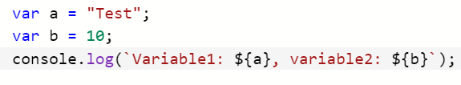



**47) Check if the string starts with 'Hi'**

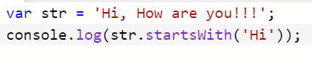

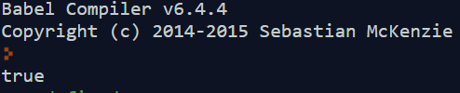

**48) Check if the string ends with 'Thanks'**

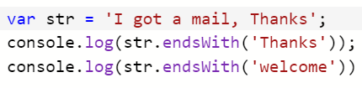

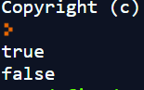

**49) Check if 'lo' is present in 'Hello World'**

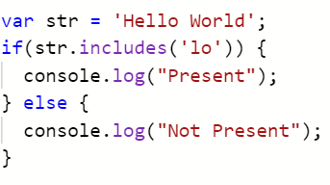



**50) What are the ways to create an array variable?**

**i) using new keyword**

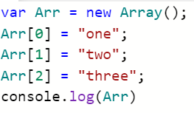



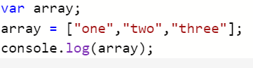



**51) Declare an array of size 5 & Initialize the array with 5 for all the elements**

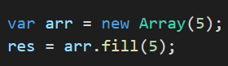

**52) How to get present date in millisecond at the present time?**

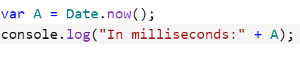



**53) What is purpose of parsing a date?**

It parses the date string to milliseconds.

For comparison purpose we are parsing the date.

**54) Convert a date in UTC format to "YY-MM-DD","MM-DD-YYYY","MM/DD/YYYY","DD MON YYYY"**

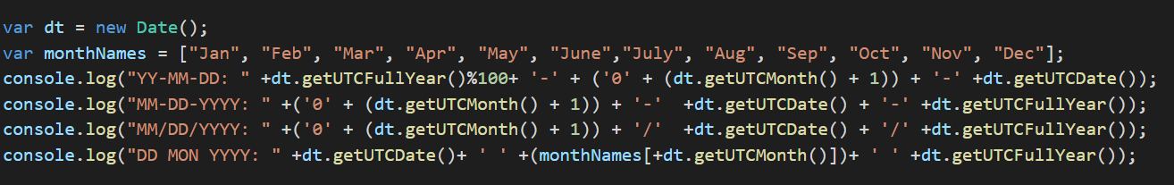

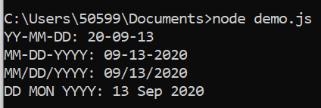

**55) Get me the below mentioned variable in ISO string and UTC string: var dateValue = new Date(2020, 9, 11, 19, 30, 33);**

**i) ISO string**

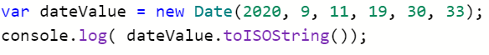



**ii) UTC string**

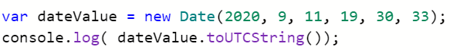



**56) Get me UTC Date, Month, Fullyear for below: var dateValue = new Date("September 20, 2020 11:00:00")**

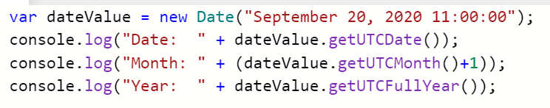

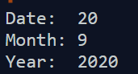

**57) Compare two date and show the number of days difference between those two.**

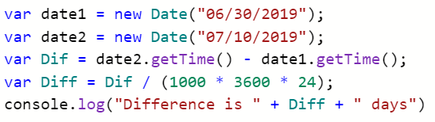



**58) How to use Setdate in below value: var dateValue = new Date("2020-9-10");**

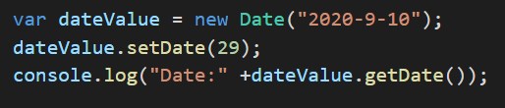

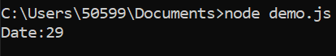

**59) Find the square and cubic root of a number**

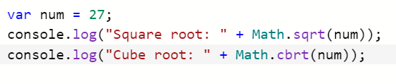

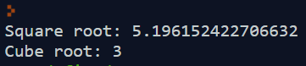

**60) Find the output of 3233^6**





**61) Round this value to a whole number var x = 3.1438222333**

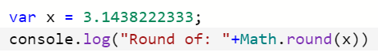



**62) What is the difference between ceil and floor**

|  |  |
| --- | --- |
| **Ceil** | **Floor** |
| Ceil returns the least value of integer ie., it is greater then or equal to the given number. | Floor returns the greatest value of integer ie.,it is less than or equal to the given number. |
| Syntax: Math.ceil(x); | Syntax: Math.floor(x); |
| Example:  Output: | Example:    Output: |

**63) How to find the min and max values in list of numbers?**

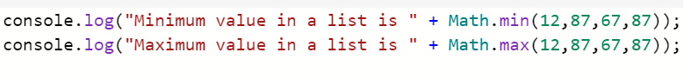

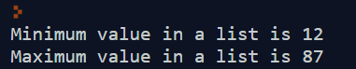

**64) check if all the elements in an array - [1,2,3,4,abc,euy,6,7] is number**

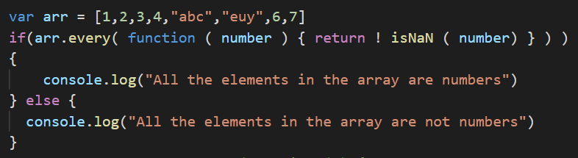

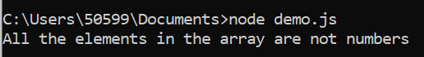

**65) print all the elements in an array (one by one)**

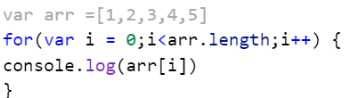



**66) Merge or combine two array**

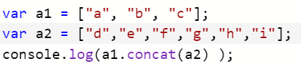



**67) remove value 3 from array - [1,2,3,4,5] & print the array**

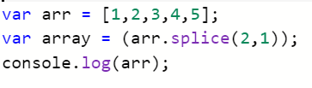



**68) filter the string values in array - [1,2,3,4,abc,euy,6,7]**

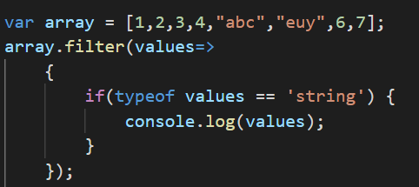

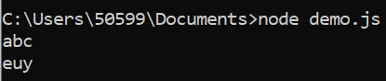

**69) Diff between unshift() & push()**

|  |  |
| --- | --- |
| **Unshift()** | **Push()** |
| It adds the element at the start of the array. | It adds the element to the end of the array. |
| Syntax: | Syntax: |
| Example:    Output: | Example:    Output: |

**70) Why do we need to clone an array?**

To avoid creation of an object that already exists

It returns the exact length of the array.

**71) Arrange the array in ascending & descending order - [23,46,62,46,24,33]**

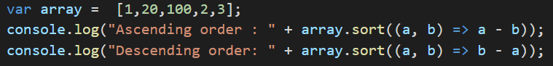

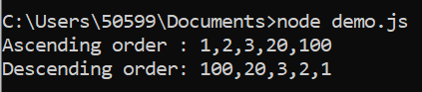

**72) find the sum of all elements in an array**

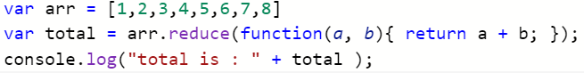



**73) print all the elements in an array (one by one)**





**74) Check if the following numbers (3, 0, 17) is present in array - [1,2,3,4,abc,euy,6,7] & print each result separately**

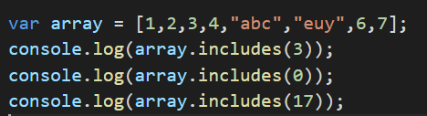

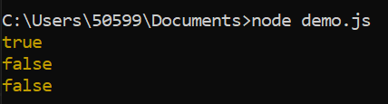

**75) print all the elements in an array from last to first element**

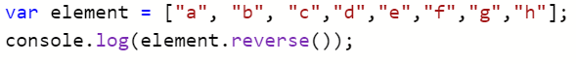



**76) Diff between find() & filter() in array**

|  |  |
| --- | --- |
| **Find()** | **Filter()** |
| It will find if one of the element is satisfying the condition. | It gives all the element that satisfies the given condition. |
| Example:    Output: | Example:    Output: |

**77) create a new array by multiplying elements from [1,4, 5] with 2**

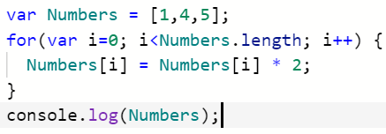



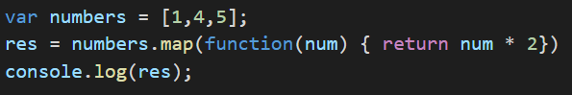

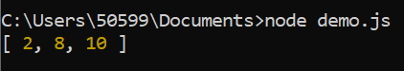

**78) Convert ['Hello','World','First','Program'] to 'Hello World First Program'**





**79) Diff between shift & pop**

|  |  |
| --- | --- |
| **Shift** | **pop** |
| It removes the first element from the array. | It removes the last element from the array |
| Syntax: array.shift(); | Syntax: array.pop(); |
| Example:    Output: | Example:    Output: |

**80) Add 4,5 in array - [1,2,3,6,7] after number 3**

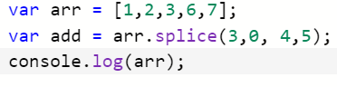



**81) create a new array with last 3 elements from array - [23,46,62,46,24,33]**

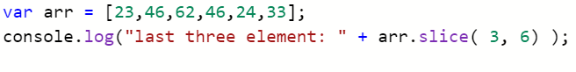



**82) Diff between every() & some() in array**

|  |  |
| --- | --- |
| **Every()** | **Some()** |
| If every element in this array satisfies the condition, its returns true else false. | If some element satisfies the condition, then it returns true, otherwise false. |
| Syntax: array.every(callback[, thisObject]); | Syntax: array.some(callback[, thisObject]); |
| Example:    Output: | Example:    Output: |

**83) print the elements of array using entries()**

**​** 